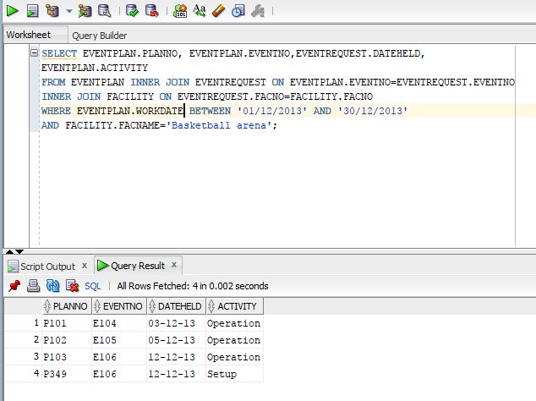
SELECT EVENTPLAN.PLANNO, EVENTPLAN.EVENTNO, EVENTREQUEST.DATEHELD, EVENTPLAN.ACTIVITY FROM EVENTPLAN INNER JOIN EVENTREQUEST ON EVENTPLAN.EVENTNO=EVENTREQUEST.EVENTNO INNER JOIN FACILITY ON EVENTREQUEST.FACNO=FACILITY.FACNO WHERE EVENTPLAN.WORKDATE BETWEEN ‘01/12/2013’ AND ‘30/12/2013’ AND FACILITY.FACNAME=’Basketball arena’;

